Installation Guide
This part is for technical person who understand magento2, shell command and server.
After download this extension and Unzip file.
1 – Go into unzipped folder
2 – Copy all file to {Magento 2 Root Folder}/app/code/HesabePayment/Hesabe
3 – Run two shell commands:
php -f bin/magento setup:upgrade
php bin/magento setup:static-content:deploy

Configuration Guide
- Login to admin panel.
- Go to Store > Configuration.
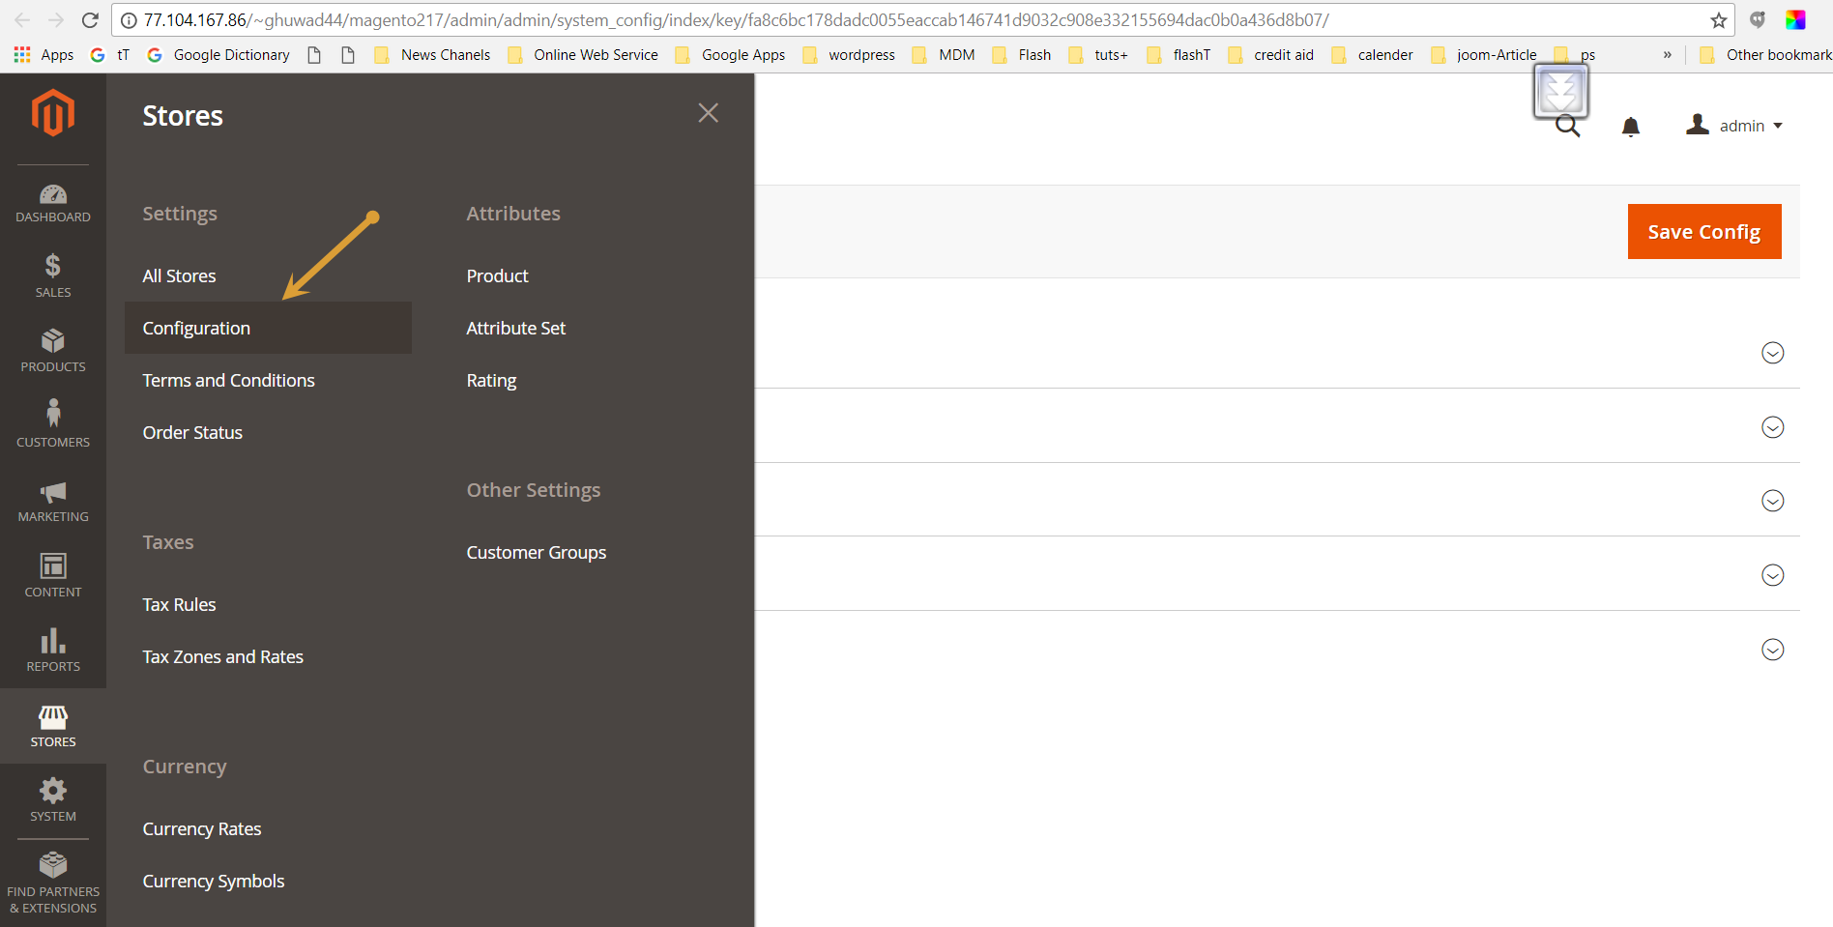

- In left navigation, go in Sale > Payment Methods sections.
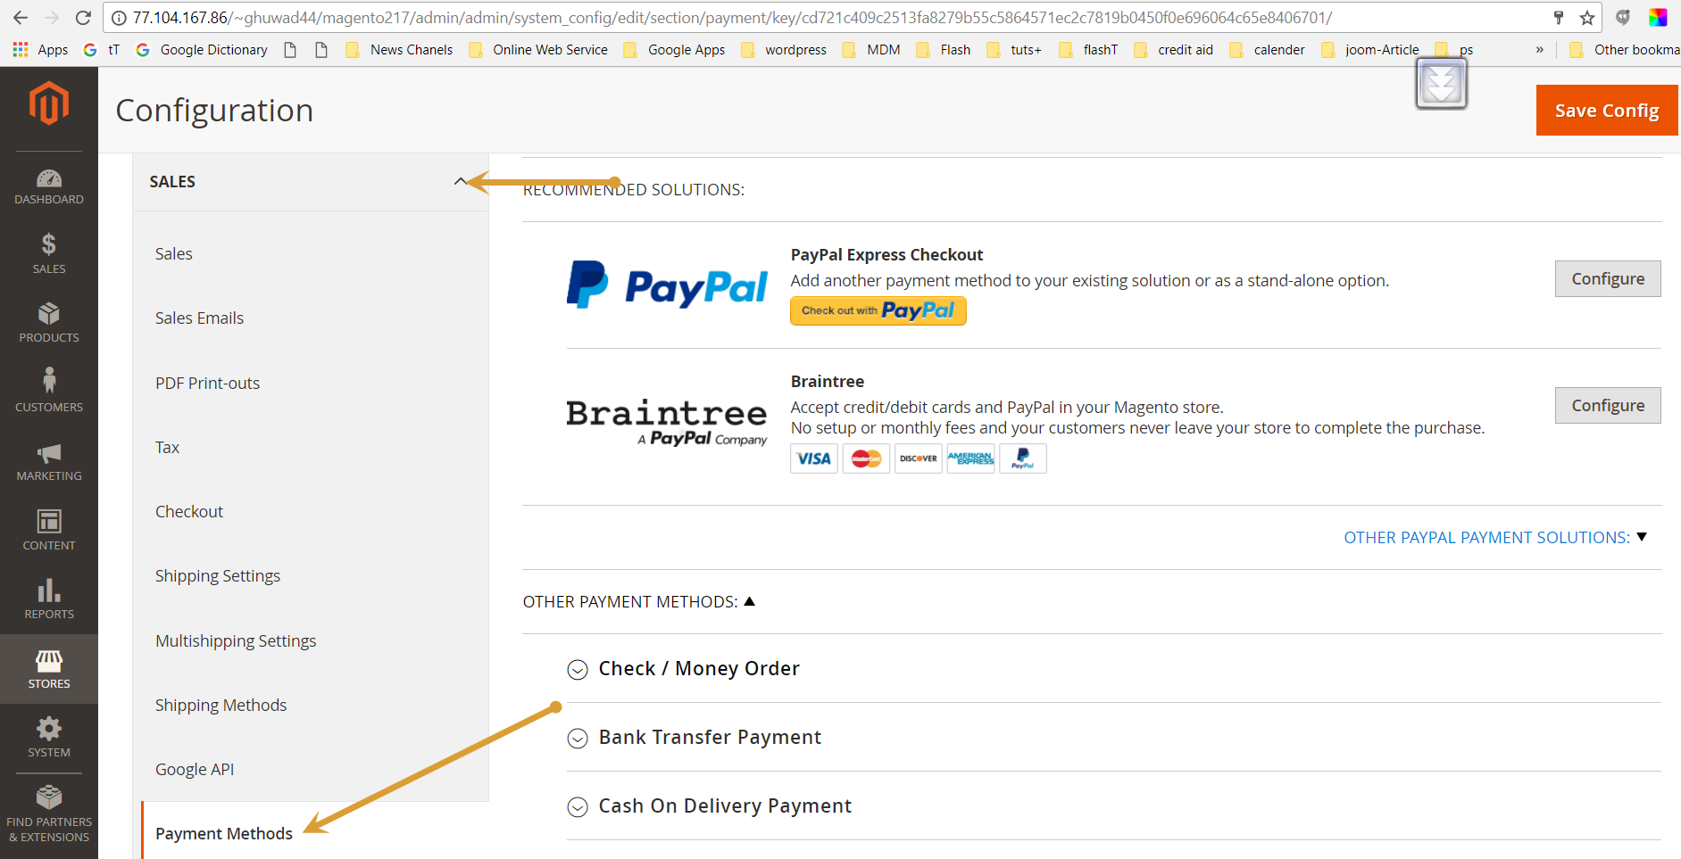

- Open Hesabe payment gateway method.
- Set parameters
- Enabled = Yes
- Title = K-Net / Credit Card, which ever you want to display at front site on checkout page.
- Set Mode = Demo or Live (If set mode is demo then admin have to enter merchant code for demo merchant account. If set Mode is Live then have to enter merchant code of Live merchant account)
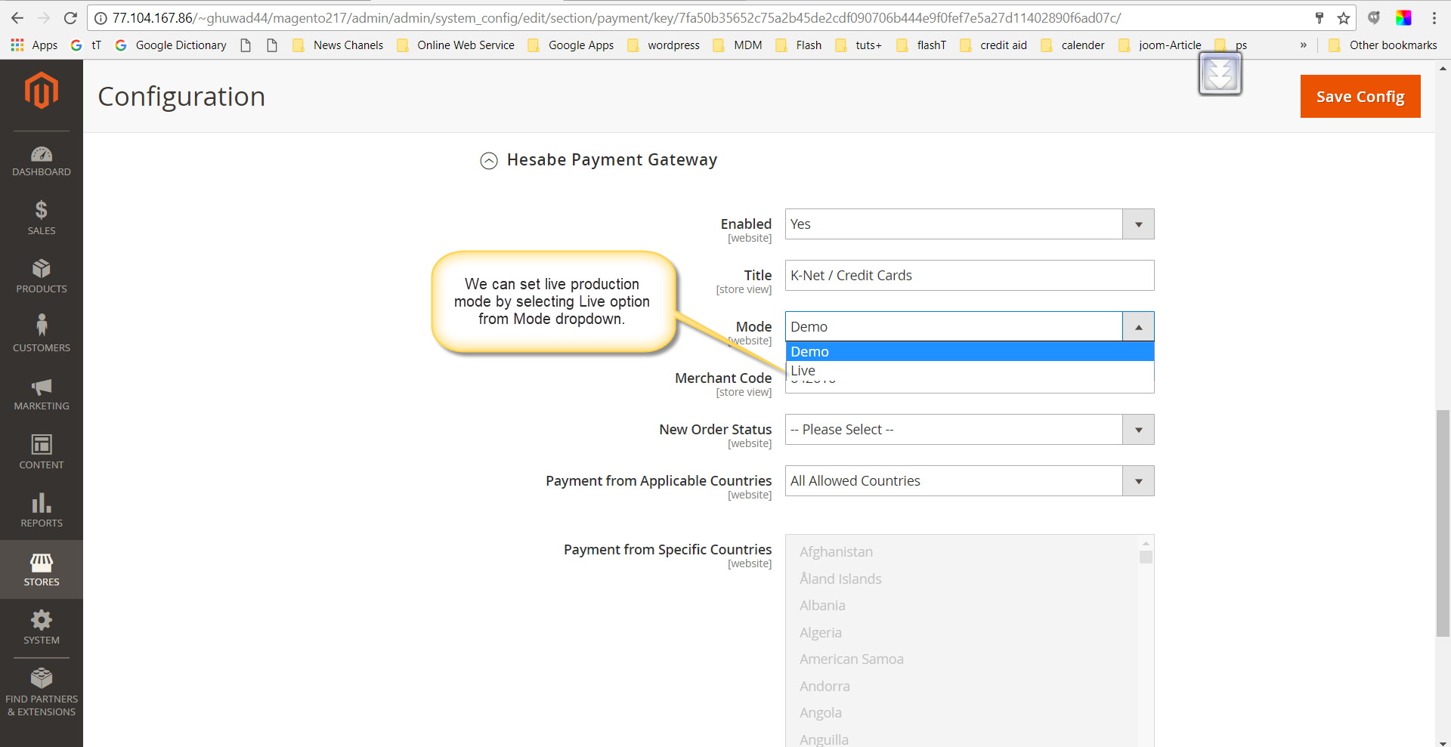
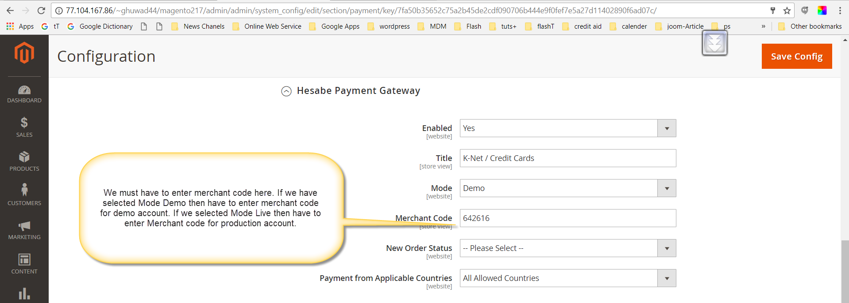

- After filling configuration detail for merchant account, need to click on Save Config button.

